Parent or Legal Guardian and Student Complaints Procedure

At NCIS, we understand the importance of a constructive feedback mechanism for continuous improvement. To ensure your complaint are addressed effectively, we have outlined a detailed complaints procedure, Policy Availability, it is available on the school’s official website. Parents/guardians and students are encouraged to review the policy online for full details and updates.

- Informal Resolution:

- Teacher/Staff Level:

Contact the respective teacher or staff member directly either through email or by scheduling a meeting.

Clearly articulate your complaint, providing specific examples and any relevant documentation.

Allow the teacher/staff a reasonable timeframe to respond, fostering open communication.

- Grade Level Coordinator or Subject Head:

If the complaint persists, escalate the matter to the Grade Level Coordinator or Subject Head.

Provide a written summary of the complaint, including previous communication attempts and outcomes.

- Formal Complaint Procedure:

- Principal/Head of School:

In the event of unresolved complaints, submits a formal, written complaint to the Principal or Head of School.

Clearly outline the nature of the complaint, including dates, times and any supporting evidence.

Ensure your contact details are included for communication purposes.

- Formation of a Complaints Review Committee:

The Principal/Head of School will appoint a Complaints Review Committee comprising impartial individuals.

The Committee will acknowledge receipt of the complaint and initiate an investigation.

- Investigation:

The Committee will gather statements from all parties involved, conduct interviews, and review relevant documents.

A transparent and thorough investigation will be conducted accordingly, with updates provided to the parent/guardian/student as needed.

- Decision and Resolution:

Based on the investigation, the Committee will provide a written decision and propose a resolution.

The decision will be communicated to the parent/guardian/student accordingly.

- Appeal Process:

- Board of Directors：

If dissatisfied with the resolution, the parent/guardian/student may submit a written appeal to the Board Directors.

The appeal should clearly outline the reasons for disagreement and any additional information.

- Board Review:

The board will review the appeal, potentially conducting further investigations.

A final decision will be communicated in writing to the parent/guardian/student.

- Confidentiality:

All parties involved are expected to maintain strict confidentiality to protect the privacy of individuals and maintain the integrity of the process.

- Continuous Improvement:

The school will use feedback from complaints to identify areas for improvement and implement changes as needed.

Periodic reviews of the complaint procedure will be conducted to ensure its effectiveness.

We appreciate your commitment to maintaining a positive learning environment, and your feedback is instrumental in our ongoing efforts for improvement.

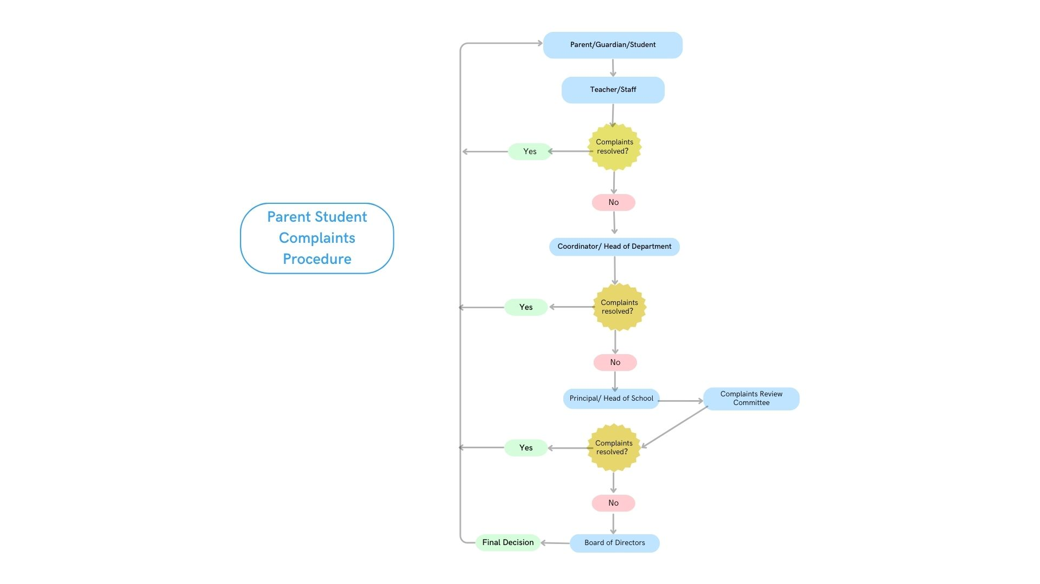

Policy Review
Published | August 2020
Last Review Date | September 2025
This policy will be reviewed and revised annually.

家长/监护人及学生申诉流程
在南昌国际学校，我们深知有效的反馈机制对持续改进的重要性。为确保您的意见得到及时妥善处理，学校已制定详细的投诉处理流程。相关《投诉处理政策》全文可在学校官网查阅，我们鼓励家长、监护人与学生通过在线渠道了解政策详情及最新更新。
一、非正式解决阶段
- 教师/员工层面
  - 通过邮件或预约会面直接联系相关教师/员工
  - 清晰陈述申诉事由，提供具体事例及相关证明材料
  - 给予教师/员工合理响应时间，保持开放沟通
- 年级组长/学科组长层面
  - 若问题未解决，可向年级组长或学科组长提交申诉
  - 提供书面申诉摘要，含既往沟通记录及处理结果
二、正式申诉程序
- 校长层面
  - 提交正式书面申诉至校长办公室
  - 明确陈述申诉性质，附具体时间节点及佐证材料
  - 注明有效联系方式以便跟进
- 申诉审议委员会
  - 校长将委任由公正人员组成的申诉审议委员会
  - 委员会确认受理后启动调查程序
- 调查流程
  - 收集各方陈述，开展面谈，审阅相关文档
  - 实施透明彻底的调查，适时向申诉方更新进展
- 决议与解决方案
  - 委员会根据调查结果出具书面决定及解决方案
  - 最终决定将正式送达家长/监护人/学生
三、上诉机制
- 校董事会层面
  - 对处理结果不满意可向校董事会提交书面上诉
  - 上诉材料需明确列明异议理由及补充证据
- 董事会审议
  - 董事会审核上诉材料，必要时开展补充调查
  - 最终裁定将以书面形式送达申诉方
四、保密条款
所有参与方均须严格遵循保密原则，维护个人隐私及程序公正性
五、持续改进
- 学校将通过申诉反馈识别改进领域，实施优化措施
- 定期评估申诉流程有效性并持续完善
我们珍视您为维护积极学习环境所做的努力，您的反馈将助力我们不断提升教育服务质量。
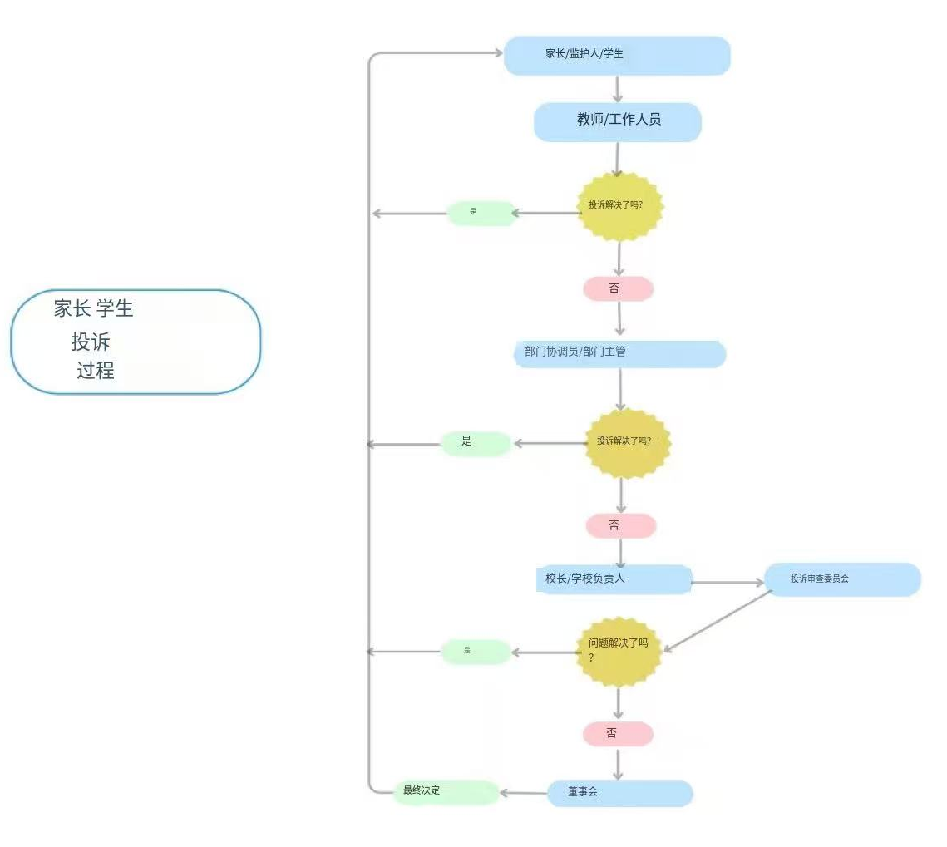
政策审议信息：
发布时间：2020年8月
最后审议日期：2025年9月
本政策将保持年度审议与修订机制。

